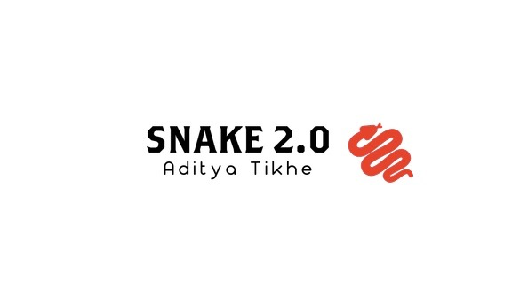

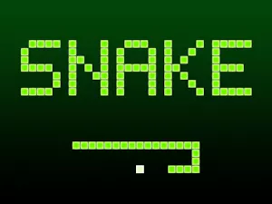

I wanted to do a project that encompassed various skills I have learned over the last three years of taking computer science classes and self-learning. This ultimately led me to make Snake 2.0 with various features. I wanted to learn how to make, utilize, and edit a database to save the scores that were achieved. Also, I wanted to create a simple AI snake bot. This project was very grand in scale because of all the features I wanted to pack into it. This led me to start early so I can brush up on the various topics I planned to use in this project. I ended up completing 97% of the project. I managed to create a working GUI frame with a working snake game a user can play and can upload their high scores to my SQL database. Also, there is a brute force solver that solves snake for you. Finally, there is an AI button which almost plays Snake. The reason why this project is not 100% done is that there are always additions to be made to the game. I could make a settings button, more features, and even upload it to the internet. The possibilities are endless! Also, there are some bugs with the AI that cause it to run into itself from time to time. I learned most of this material from youtube tutorials. I also skimmed many websites such as Geeks for Geeks to program snake and review GUI.

My most important learning experience was about SQL, a language to manage data held in a relational database management system. I started off with popSQL, a SQL editor, to relearn commands and how to work with tables. After having enough practice with tables and adding data, I tried to connect it and access it from my game program. I then made a class that updates the database whenever the execute commands. This was by far the most important discovery and learning for the whole project. This is because it was something outside of java I can connect to it. I have worked with APIs but that was with supervision. This project let me develop a database system through trial and error. I then added commands to filter data to see only the top 5 scores. By doing this by myself, I will remember how to connect SQL to any project in the future.

I have also learned about Artifical Intelligence and its power. AI has always been a distant topic to me as I’ve heard about it in the news and never got to actually to work with it. I took my first shot at it by reading articles on it. Many sources consider AI as many if statements that work in unison to make something appear as it works autonomously. That is what I did as I tried to perfect the motion of the snake to make a somewhat efficient path to the next apple. To be honest, I am still struggling how to make it so that get outs of its own body and not run into itself. This will take some time, but I will learn on it in the summer. I also want for the snake to learn from its mistake, but that will probably take a while.

I struggled to learn about SQL as there were many ways to make a database for my game. I chose SQL over the Oracle database because of its simplicity. After grasping SQL the main challenge was learning how to connect it to java. My game was written in Java, so I had to establish a JDBC connection to it. I then made methods that are called whenever a user wants to add their data to the database. The real issue was managing it from my game. I had to delete and add code for the table to work as I wanted it to. For example, I couldn’t keep the code to create a table whenever I ran it, so I had to run it once and delete it or else I would get a duplicate table error. This took a while for me to wrap my head around because I wasn’t used to code working one time and not the next. I was used to building something, perfecting it and then building upon that. This experience made me realize that every language has its own unique quirks and has different purposes.

My next steps are to just expand on this project and perfect what I have made. I will do this by reducing lag on this project because sometimes the game modes slow the speed of the snake. I could potentially make some O(n) code into O(1). Most importantly, I want to make the AI snake better. I want to reduce unnecessary crashes into itself. After I have worked on these fixes, I want to make the application better. I could make different maps or even modes. I plan to focus on this project more after the school year ends so I can devote more time to it. If on the off chance I choose to give up on this project, I want to use my knowledge on SQL to make another game or possibly something more intricate. I have been eyeing many other projects in this class after hearing about them. For example, I want to develop a genetic algorithm as Joel did. Paired with a SQL database I feel like this project has the potential to be powerful. I just want to work on more meaningful projects before I go to college for my own learning and to build my resume.

I personally loved working on this project because it allowed me to work with my own timeline. I got to start this project when I wanted to and learn the concepts I wanted to implement. This led me to start earlier than during the AP exam weeks so I could review SQL. I started around the time of HooHacks and thus got to implement what I learned there. Furthermore, working by myself led me not to depend on anyone else. This also gave me a sense of pride because I completed a project end to end by myself. The topic I learned about was very powerful as databases are the back end of most projects. Though I didn’t do the best job with AI, I see the power of it. When comparing it to the brute force solver, I see how much less time AI takes. All in all, I believe I have learned a lot this year not just about Java, but also about myself.